Canton City Health District  420 Market Avenue North  Canton, Ohio 44702-1544  Phone: (330) 489-3327 • Fax: (330) 489-3335  Web: www.cantonhealth.org | 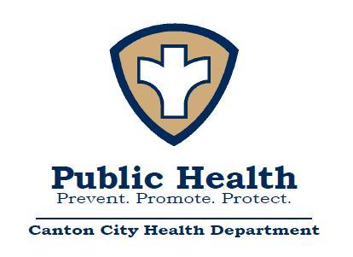
James M. Adams, RS. MPH
Health Commissioner

Declaration and Order to Abate a Public Health Nuisance

August 30, 2016

Mr./Mrs./Ms. NAME
POSTING ONLY

Mr./Mrs./Ms. NAME:
You are hereby notified that the Board of Health of the Canton City Health District at their regular meeting on MONTH DAY, YEAR made the following order:
Under authority of section 3707.01 of the Ohio Revised Code, it is the opinion of the Board of Health of the Canton City Health District that the accumulation of junk, garbage, rubbish, and trash, on the property located at ADDRESS, Canton, OH is a public health nuisance and that you are responsible for correcting these conditions. You are hereby ordered to abate this public health nuisance by MONTH DAY, YEAR, and maintaining the property in a clean, nuisance free condition. Such abatement is to be completed by MONTH DAY, YEAR.
Failure to comply with this order may result in the Canton City Board of Health furnishing the materials and labor necessary to abate this nuisance and the cost of such abatement being placed as a lien upon your property to be collected as regular taxes as provided in Ohio Revised Code section 3707.02. Additional criminal or civil action may be taken as necessary to secure compliance with this order.

By Order of the Canton City Board of Health

BY: ____________________________________
James M. Adams, RS, MPH
Secretary, Canton City Board of Health

20161148

